**Sprint 3 Plan - RetailGo - 11/11/23**

Goal: Complete customizable Point-of-Sales application (integration of payment included) and intelligent add-ons for inventory management.

**Task listing:**

* **User Story 1:** As an employee, I want to be able to process client transactions in the store, so I can process sales.
  + Name/Product Search [FE] (2)
  + Unit Test POS Routes [BE] (4)
  + Test POS Page/Inventory (1)
  + Integrate Stripe API (8, overflow from last sprint)
  + **Total: 15 hours**
* **User Story 2:** As an employee, I want to be able to customize the POS interface to my store, so I can improve my efficiency.
  + Implement customizable Frontend (10)
  + Store POS Preferences [BE] (2)
  + **Total: 12 hours**
* **User Story 3:** As an owner, I want to be able to manage my employees, so that there’s no unauthorized access to my store inventory or POS.
  + Employee Management UI/UX (3)
  + Employee Management Frontend (5)
  + Employee Management Backend (4)
  + **Total: 12 hours**
* **User Story 4:** As an owner, I want to better understand my store sales and stocks, so that I can improve sales.
  + Dashboard (4)
  + Create Image Upload (10)
  + Implement collaborative filtering recommendation engine (15)
  + **Total: 29 hours**
* Additional Tasks:
  + Category auto-labeling (5) [STRETCH]
  + Add Static Analysis (2)
  + OpenAPI Compliance (2)
  + Host Backend on AWS (6) [STRETCH]
  + Complete and Finalize Backend Unit tests (8)
  + Frontend Alternate View (3, overflow) [STRETCH]
  + Database redesign [Create new table for Categories] (4)
  + **Total: 16 - 30 hours**

**Team Roles:**

* David Nguyen -> Developer
* Apramay Singh -> Developer & Product Owner
* Jonathan Michel -> Developer
* Leo Asatoorian -> Developer
* Giridhar Vadhul -> Developer & Scrum Master
* Colby Frey -> Developer

**Initial Task Assignment:**

* David Nguyen - > (User Story 1) Name/Product Search (POS)
* Apramay Singh -> (User Story 4) Dashboard Design
* Jonathan Michel -> (User Story 2) POS Backend
* Leo Asatoorian -> (User Story 1) Stripe API Integration
* Giridhar Vadhul -> (User Story 4) Recommendation Engine
* Colby Frey -> (User Story 3) Employee Management UI/UX

**Initial burnup chart - Sprint 3**

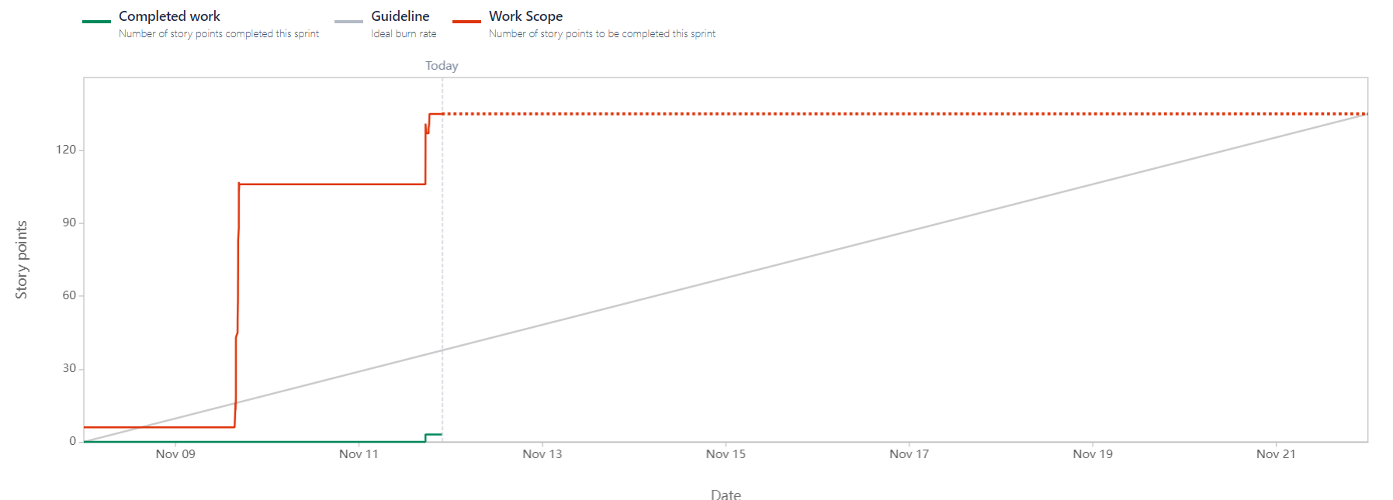

**Initial scrum board**

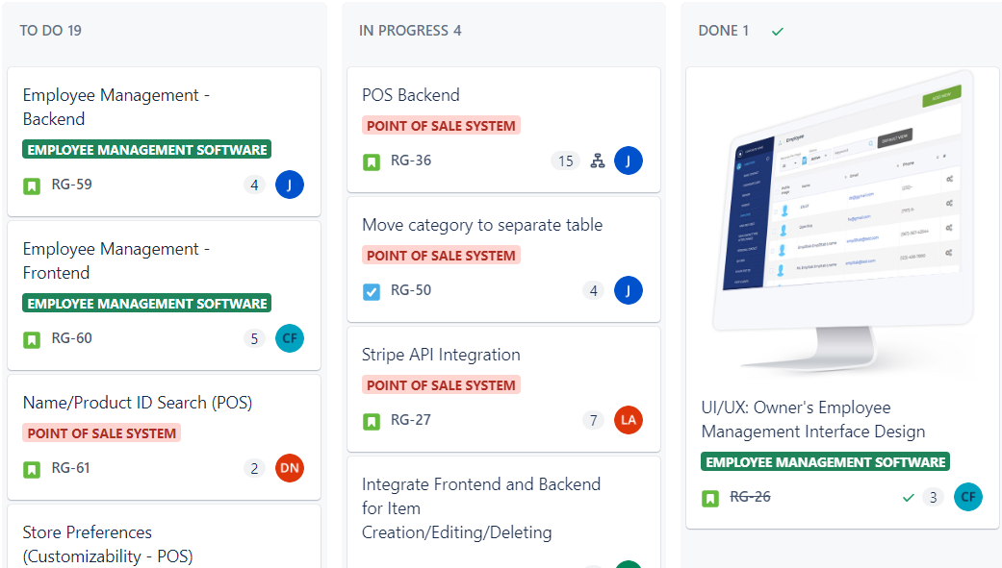

**Scrum Times:**

* Monday -> 4-6pm (including TA meeting)
* Thursday -> 4-5pm
* Saturday -> 4:30-5:30pm

**Code Coverage and Standards:**

**Code Style Standards:**

* [Go Standards](https://google.github.io/styleguide/go/)
* React Standards (Custom - under formulation)

**Code Coverage:**

For this sprint, we are aiming for at least 80% code coverage for the backend (using Go-Test), and intend to refactor the existing backend code to conform to the Google Go Standards by the end of the sprint. Further, we will be refactoring our routes to conform to the OpenAPI specification, and using it to generate documentation for our backend APIs.

Code coverage will be measured against our unit tests, triggered by a Github Action in our CI/CD pipeline to test each commit.